- Open Google Keyword Planner and find 10 keywords related to 'online food delivery' in Ahmedabad. List their average monthly searches and competition level.

Keyword | Avg. monthly searches | Three month change | YoY change | Competition | Competition (indexed value) | Top of page bid (low range) | Top of page bid (high range)
online food delivery in ahmedabad | 50 | 0% | -90% | Medium | 37 | 5.81 | 41.84
online food order ahmedabad | 500 | 0% | 0% | Medium | 39 | 5.02 | 34.14
food delivery ahmedabad | 500 | 900% | 0% | Medium | 38 | 8.96 | 49.13
food delivery app ahmedabad | 500 | 0% | 0% | Medium | 34 | 8.15 | 55.48
24 hours food home delivery in ahmedabad | 50 | 0% | 0% | Low | 25 | 7.42 | 37.88
food delivery app in ahmedabad | 500 | 0% | 0% | Medium | 34 | 8.15 | 55.48
best food delivery app in ahmedabad | 50 | 0% | 0% | Medium | 47 | 11.05 | 44.24
zomato online order ahmedabad | 50 | 0% | 0% | Low | 5
swiggy online order ahmedabad | 50 | 0% | 0% | Low | 10 | 2.63 | 21.45
ahmedabad food delivery app | 50 | 0% | 0% | Medium | 36 | 6.84 | 41.73
ahmedabad tiffin home delivery | 50 | -100% | -100% | Unknown
food online ahmedabad | 50 | 0% | 0% | Medium | 47 | 2.32 | 26.63
food order ahmedabad | 50 | 0% | 0% | Medium | 36 | 8.38 | 27.42
home delivery food ahmedabad | 50 | 0% | 0% | Low | 25
late night food delivery in ahmedabad | 50 | 0% | 0% | Low | 4
mcdonald ahmedabad online order | 50 | 0% | 0% | Medium | 36
midnight food delivery in ahmedabad | 50 | 0% | ∞ | Low | 0
non veg home delivery in ahmedabad | 50 | ∞ | ∞ | Low | 0
om food center chandkheda | 50 | -100% | 0% | Unknown
online food delivery app in ahmedabad | 50 | 0% | 0% | Medium | 65 | 12.49 | 50.37
swiggy online food order ahmedabad | 0 | 0% | 0% | Unknown
zomato ahmedabad online order | 50 | 0% | 0% | Low | 6
zomato food delivery in ahmedabad | 0 | 0% | 0% | Unknown
zomato order online ahmedabad | 50 | 0% | 0% | Low | 6

- Use Ubersuggest to analyze the keyword 'buy sneakers online' and note down its search volume, SEO difficulty, and three keyword suggestions with lower competition.
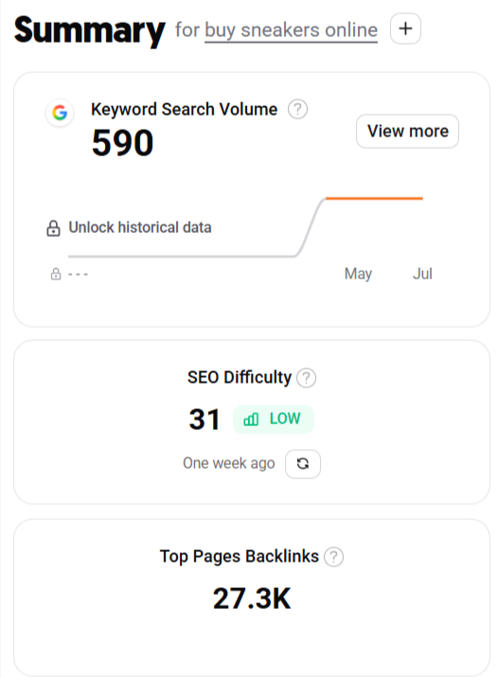
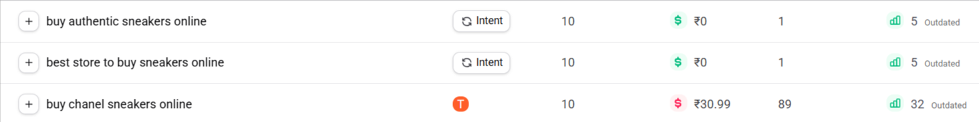
- Go to AnswerThePublic, enter the keyword 'digital payments', and write down 5 unique question-based keyword ideas that appear in the results.<br><br><em><strong>Hint:</strong> Look for 'what', 'how', or 'why' type questions in the visualization or data view.</em>
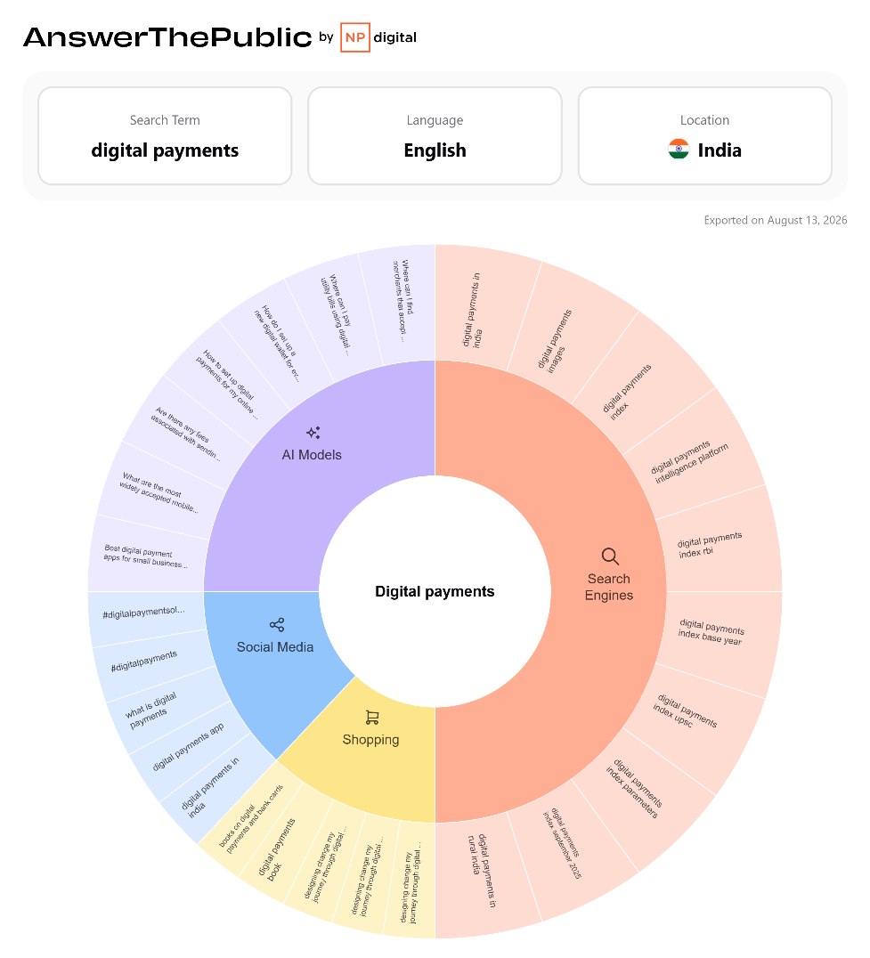
- Try the Google Autocomplete hack by typing 'best headphones for' into Google Search and record 8 autocomplete suggestions you see. Explain how these suggestions can help you create content for an e-commerce site like Flipkart.
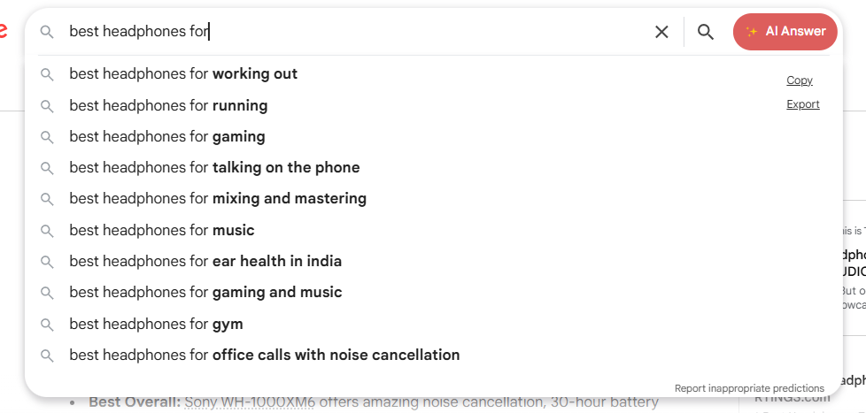

How this helps an e-commerce site like Flipkart
These suggestions reveal what customers actually want headphones for. Flipkart could use them to:
- Create SEO pages such as “Best Headphones for Gaming”.
- Create category filters for Gaming, Running, Work, Travel, and Calls.
- Write blog articles targeting long-tail keywords.
- Optimize product descriptions using relevant phrases.
- Create separate landing pages for different customer needs.

- Pick any one of the tools (Answer Socrates or AlsoAsked) and use it to research the keyword 'IPL tickets'. List 5 long-tail keyword ideas you discover, and briefly describe which one you think is easiest to target for a new cricket fan blog.
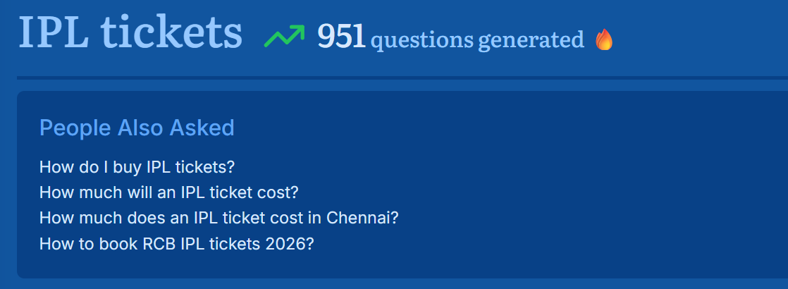
Easiest to target for a new cricket fan blog. “How do I buy IPL tickets?” I would choose this one because it is specific, question-based, and useful for beginners.

